Name: Cria Kay

UmichID: criakay 9758 2157

What dataset are you working with: steak_survey (for the first two) and drinks (for the last one)

List 3 questions that you can ask with your dataset.

Q1: Is there a difference between how women and men like their steak?

Q2: Is there a difference between steak preferences between people who skydive and those who do not?

Q3: Is there a difference between the servings of wine in France as compared to the global servings of wine in the average serving size?

List the associated null hypothesis for each question:

Q1: There is no difference between how women and men like their steak.

Q2: There is no difference between how people who skydive and people who do not skydive like their steak.  
Q3: There is no difference between the servings of wine in France as compared to the global serving of wine in the average serving size.

What statistical test(s) will you use to answer each of the questions:

Q1: Chi-Squared

Q2: Chi-Squared

Q3: T-test

Make a visual plot showing the relationship that you will analyze statistically (e.g. boxplot for t-test or ANOVA; scatterplot for regression; table for chi-square).

Q1: 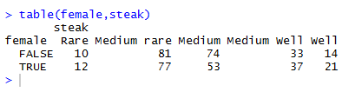

Q2: 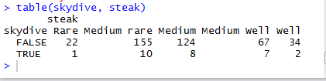

Q3: 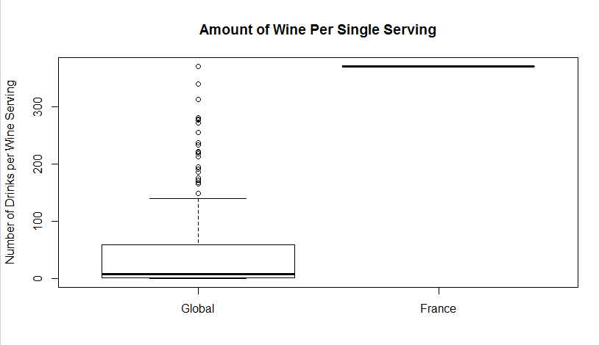

Do your data meet the assumptions required for the statistical test you want to run? Please state the assumptions you examined and whether or not your data meet those assumptions:

Q1: Sample is randomly selected from the larger population (I am assuming it is), assumptions must be independent of each other, must have observations in each of the cells in the contingency table (there was).

Q2: Sample is randomly selected from the larger population (I am assuming it is), assumptions must be independent of each other, must have observations in each of the cells in the contingency table (there was).

Q3: Data are continuous (assuming so), sample is randomly selected from population, observations are independent (assuming so), sample size is large enough or values are nearly normal (There are over 30 samples for the variable)

Run the statistical test! Put your results here:

Q1: 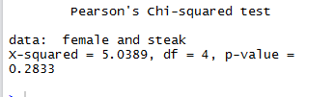

Q2: 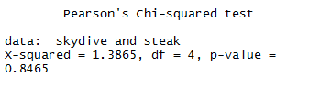

Q3: 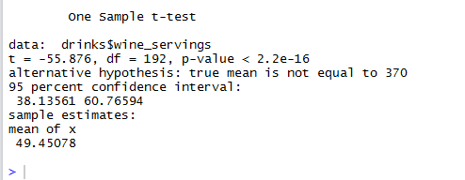

Interpret your results!

Q1: Not significant p-value—there is no difference between how men and women like their steak. Fail to reject the null hypothesis.

Q2: Not significant p-value—there is no difference between how men and women like their steak. Fail to reject the null hypothesis.

Q3: Significant p-value – there is a difference between serving sizes of wine in France as compared to the rest of the globe. Reject the null hypothesis.